Intro to Unreal Engine - Part Five
  - Polish and Publish

Overview
What are some of your favorite games? Is the information about the game displayed to the player in a way that lets you understand what is happening? Are you aware of where your score and health are located? Can you visually see what items you have in your inventory? If you have special abilities, is there a way for you to see whether they are currently available or if they are in a cool-down period? These are all elements of the User Interface (UI) or Heads-up Display (HUD). When implemented effectively, they add to the positive user experience in the game.
In this final part of the project, we will focus on:
- Heads-up Display (HUD)
- Coin and Gem counter
- Key icon
- Jump Boost icon
- Packaging the game to be played on Windows PCs.
- Adding a way for the player to close the game once it has been completed.
- Connecting existing code.
Adding and completing the above functionality will make the game more engaging as well as help players understand what is going on. This last push will take us deeper into the code and will be the most rewarding. You are 80% of the way to having a working level, and this last 20% will make your game stand out. These “quality of life” additions require more playtesting, so be prepared to engage your peers in the process!
Please alert your instructor if you come across instructions or screenshots that need to be updated for Unreal Engine 5.

Learning Outcomes
By the end of this module, learners should be able to:
- Describe how a HUD widget can be controlled by way of a Game Mode.
- Change the transparency of HUD items manually and with Blueprint code.
- Edit event graph code with a HUD widget.
- Package an Unreal Engine game as a Windows executable for distribution.

Let’s Play
Let’s place a key in front of the locked door so we can start to explore the information that can be displayed on the HUD.
To jump to the final locked door, you can click in the Viewport and press the number 5 on the keyboard to jump to the Camera Bookmark. To find the key, open the Content Browser and navigate to the Content > Hour_of_Code > Blueprints folder. Drag your BP_Key into the level front of the door (Figure 001). (We are placing an extra key in front of the door to make testing more convenient.)
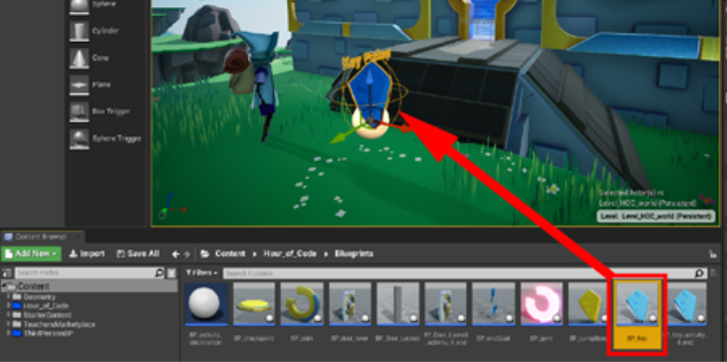
Figure 001 – Add an extra key to your level for testing purposes.
To play the game from our current location, make sure to select the Current Camera Location from the dropdown arrow next to the Play button, then click Play. Pick up the key, walk to the door, and press the E key on the keyboard. The door will open, and you will see a transparent Key icon appear in the bottom-left area of the screen (Figure 002). Then, exit the game by pressing Esc on the keyboard.
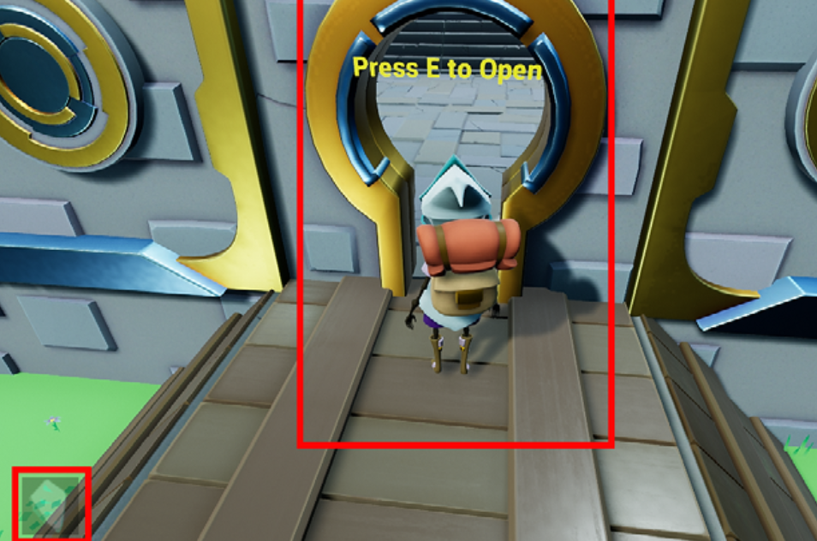
Figure 002 – The transparent key icon is revealed.
To understand what is happening we need to examine the door Blueprint. Select the door in the Viewport and then either click Edit BP_Door in the World Outliner or press Ctrl + E to open the Blueprint Editor (Figure 003). Or double click the BP_Door Blueprint in the Blueprint folder.
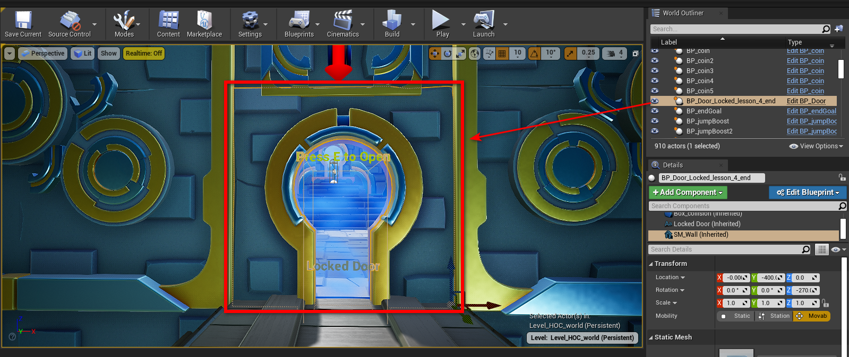
Figure 003 – Selecting and Editing the BP_Door Blueprint From the Viewport
🤝 PRO TIP FOR THE WIN
Naming conventions in Unreal: We talked about naming conventions before, but here are a few more conventions at play in this module:
Blueprint Assets Start With: BP_
Image Textures Start With: T_
UI Widgets Start With: W_
With the Door Blueprint Editor open, click on the Event Graph tab if it’s not open already. You will see a green area in the bottom right (Figure 004). Zoom in to that area using the scroll wheel on the mouse. You can pan by holding the right mouse button while dragging.
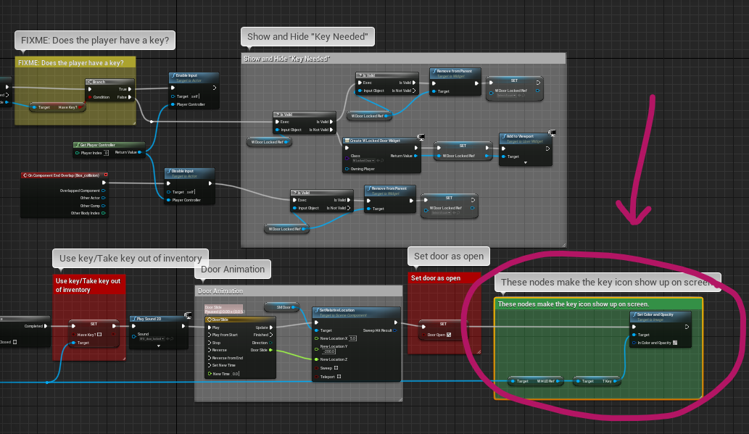
Figure 004 – The part of the Blueprint that makes the key icon visible.
Inside this area, you will see 3 nodes (Figure 005):
- A reference to the HUD Widget (W HUD Ref)
- The texture for the key icon (T Key)
- A way to control the opacity and color of the texture (Set Color and Opacity)
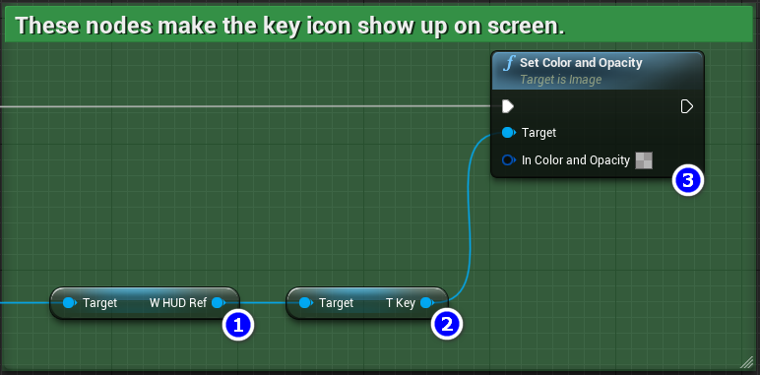
Figure 005 – The Three Nodes Involved In Showing the Key Icon
By clicking on the checkerboard, you can open the Color Picker (Figure 006). From here you can see that the opacity (a fancy word for the opposite of transparency) is being set to 0.3 or 30%. In Unreal the opacity is the “A” value of a colour. The A stands for the “alpha channel” which is another way of talking about transparency in the domain of digital colours.
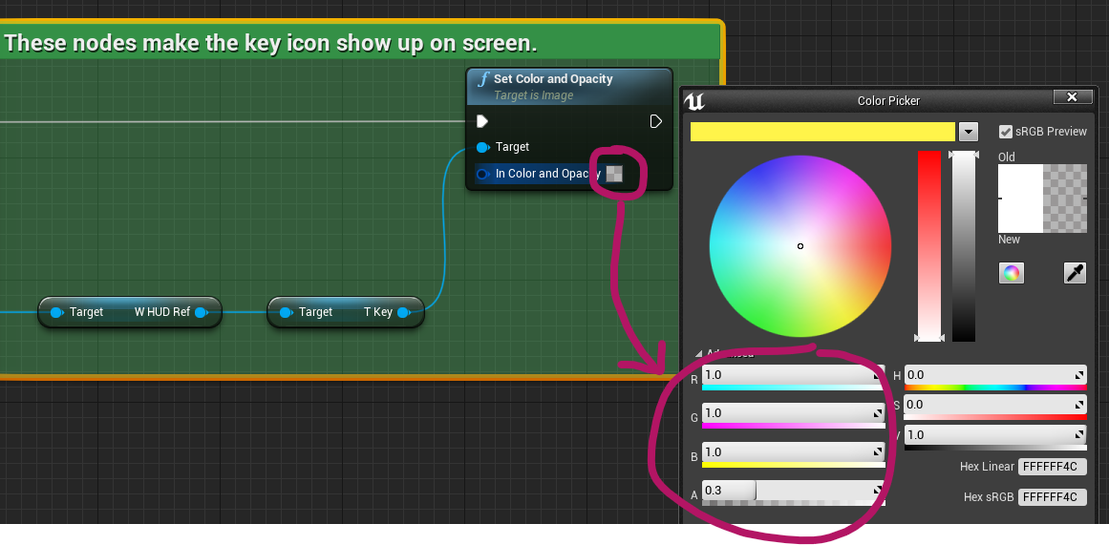
Figure 006 – Selecting a color and opacity with the color picker.
🖖 LENDING A HELPFUL HAND
Warning: Be sure to close the Color Picker after you’ve looked at the color and opacity settings. Keeping it open could cause problems later when we are done with this blueprint.
Follow the blue wire back to its origin (to the left) and you will see that the information for the HUD is being stored in the BP_HourOfCode_Game.
In part four, you may recall that we talked about how Blueprints can Cast to the Game Mode to get or set information. In this case, the door is casting to the Game Mode to get information about the HUD. Remember that the Game Mode is a special object that keeps track of logic and rules for a game. In our game, our Game Mode (BP_HourOfCode_Game) is also used to interface with the HUD.
To see how the game is controlling the HUD, you can open the Game Mode Blueprint. In the Content Browser navigate Content > Hour_of_Code > Blueprints > Game and open the BP_HourOfCode_Game by double-clicking on it.
With the BP_HourOfCode_Game Blueprint open, click the Event Graph tab if it is not already selected. Locate the blue area labeled Display HUD. Let’s review the first three nodes on the left side of that area (Figure 007). These nodes:
- Create the HUD widget. (Create W HUD Widget)
- Store a reference to the HUD in a variable. (Set W HUD Ref)
- Display the HUD to the screen. (Add to Viewport)
Close the Blueprint Editor by clicking the X in the upper-right.
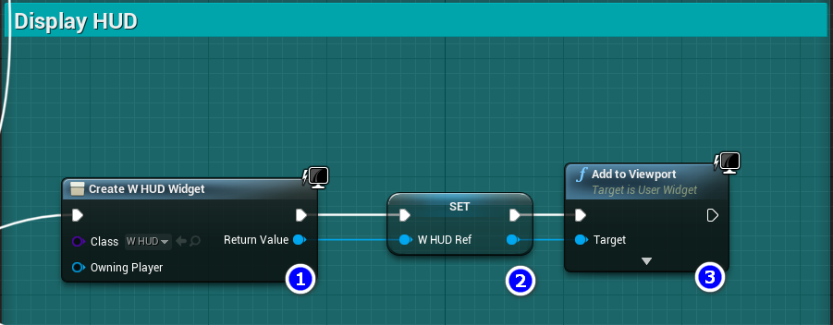
Figure 007 – HUD controls in the Blueprint Event Graph.

Working with Widgets
Let’s get the HUD Widget open. In the Content Browser, navigate to Content > Hour_of_Code > Widgets, and double-click the W_HUD.
🤖 TECHNICAL JARGON DEFINED
Widget – In Unreal Engine a Widget is a Blueprint used to design user interfaces (UI).
UMG – The UI design system available in a Widget Blueprint is call UMG, which stands for Unreal Motion Graphics.
We’ll be working with the following for UMG Widget areas (Figure 008):
- Hierarchy – This area is a list of all the elements that are being displayed on the screen. Currently, all the elements have been set to be invisible, which is why you haven’t seen them on-screen during activities 1 – 4. That’s about to change.
- Visual Designer – This is a representation of the game screen, where we have placed the key icon.
- Details – This panel will update when you select elements, like the key icon, in the Hierarchy or Visual Designer.
- Editor Mode – This will switch between Designer mode and Graph mode.
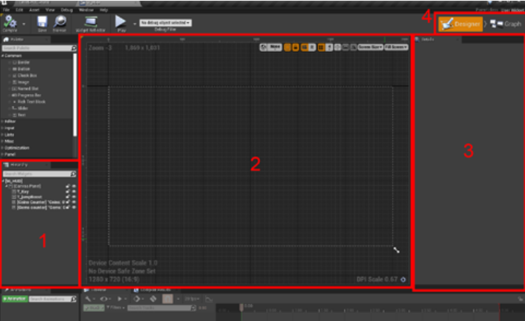
Figure 008 – The Widget Designer

The Key Icon
In this section we are going to:
- Let the player know they can pick up a key in this game by adding a transparent key icon to the HUD.
- Make the key icon fully opaque when the character picks up the key.
Follow these steps (Figure 009):
- In the Hierarchy panel, select T_key. Following naming conventions, the T_ stands for image texture.
- Make the texture transparent by changing its alpha (A) value:
  - In the Details panel, scroll down and find Color and Opacity under Appearance. (You may need to click the arrow to the left of the Color and Opacity label to expand the view.)
  - Change the A (alpha) to 0.3; you will see the faded key icon appear.
- Then, click the Compile button followed by the Save button at the top-left area of the screen.
Now when you play the game, the key icon can be seen on the screen. Close the Widget Editor by clicking the X in the upper-right corner, then click the Play button in the Unreal Editor to play your level.
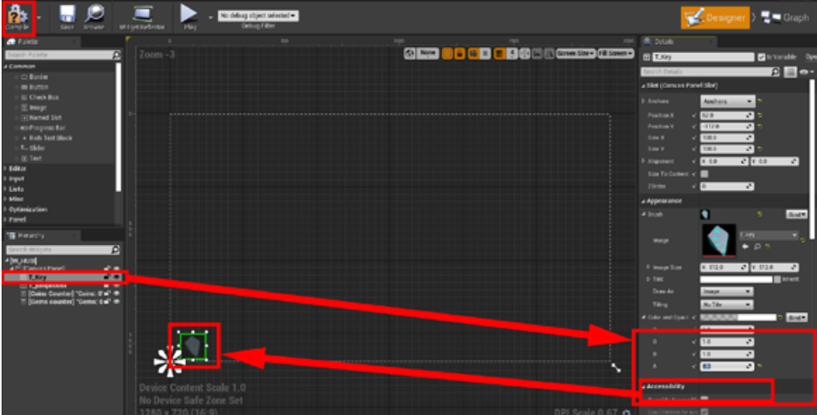
Figure 009 – Setting the Alpha value of the key hud icon to make it visible.

Activating the Key
Next, we will turn the key icon fully visible (opaque) when the character picks it up. This will be controlled by the BP_Key Blueprint. Navigate to to Content > Hour_of_Code and open BP_Key by double-clicking on it.
Let’s add nodes to make the HUD key icon turn fully opaque when the key is retrieved. To do this, we will get a reference to the HUD widget we were just working on, find the key texture (T_Key), and set the color alpha value to 1 (fully opaque):
- In the Event Graph tab of BP_Key, find the existing Cast to BP_HourOfCode_Game node and click and drag from the blue “As BP HourOfCode Game” connector (Figure 010).
- Type “GET W HUD Ref” into the search and select the GET W HUD Ref variable reference that is found (Figure 010). This is the game mode’s reference to the HUD.
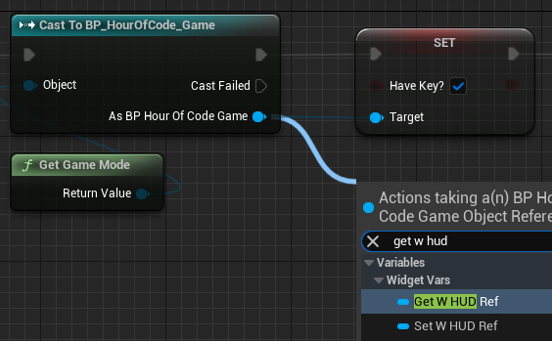
Figure 010 – Finding the “GET W HUD Ref” variable reference.
- Click and drag from the output connector of W HUD Ref node you just created. Search for “get T_Key” and pick the GET T_Key variable reference that is found (Figure 011). This is a reference to the key icon in the HUD.
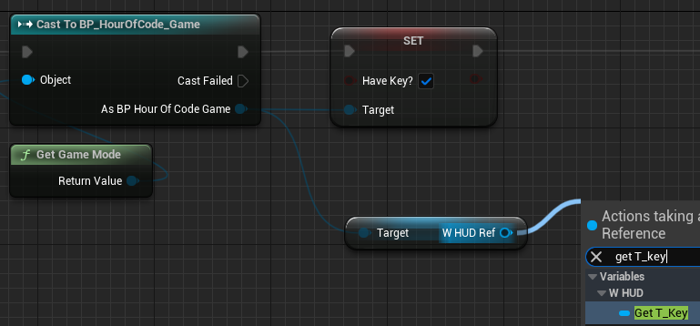
Figure 011 – Finding the “Get T_Key” variable reference.
- Click and drag from the output connector of the GET T_Key node you just created. Search for “set color” and select Set Color and Opacity (Figure 012).
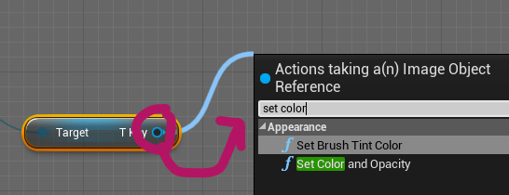
Figure 012 – Find the Set Color and Opacity node.
- In the Set Color and Opacity node, click on the square beside In Color and Opacity and ensure that the R, G, B, and A values are all set to 1.0 (Figure 013).
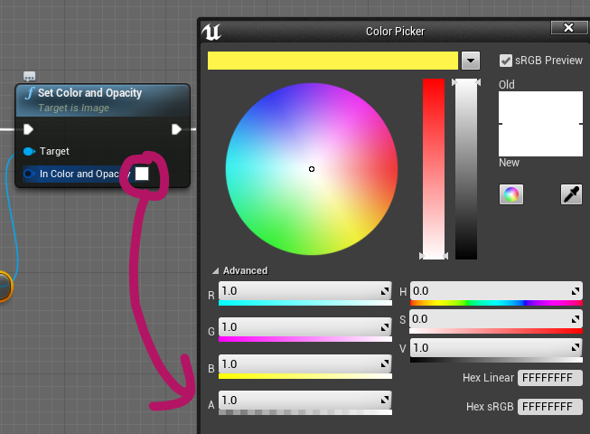
Figure 013 – Setting the Alpha transparency value for the key icon.
- Rewire your key Blueprint to match Figure 014. Note that the Set Color and Opacity node is now executed between the Set node and the Play Sound 2D node. See the follow pro tip for advice on disconnecting or moving wire connections.
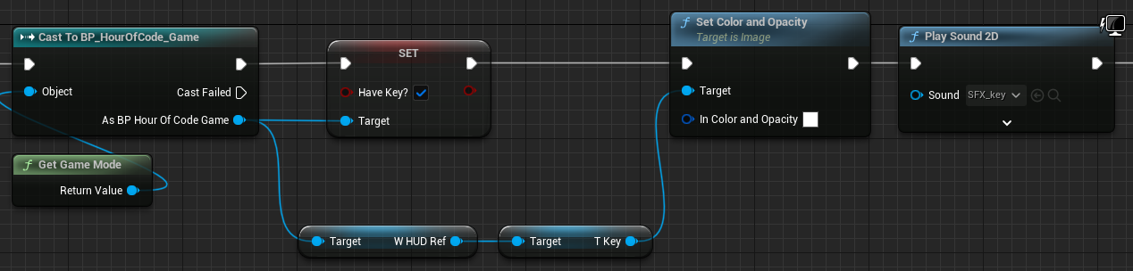
Figure 014 – Rewire your blueprint to match this image.
🤝 PRO TIP FOR THE WIN
Rewiring Tips – Hold down ALT when clicking a wired connector to remove the associated wire. Hold down CTRL when clicking a wired connector to grab the wire to place it elsewhere.
- Click the Compile and then the Save icons above the Event Graph.
Now, play the game. The HUD key icon should start semi-transparent. After you collect the key, the key icon should become opaque. Next, open the door and you should see the key icon become transparent again.
Let’s review what is happening:
- The Game Mode displays the HUD on the screen when the game begins, and the key icon is initially drawn at 30% opacity.
- When the character touches the key, it tells the Game Mode to draw the key icon at 100% opacity.
- When the player opens the door, it tells the Game Mode to draw the key icon at 30% opacity.
Well done, that was a lot of coding. Next, we will set the Jump Boost icon to behave the same way.
Remember to Save All your work.

Jump Boost’n
In this section, we will be working on 3 different Blueprints to add jump boost status to the HUD:
- W_HUD (in Content > Hour_of_Code > Widgets)
- BP_jumpBoost (in Content > Hour_of_Code > Blueprints)
- BP_HourOfCode_Character (in Content > Hour_of_Code > Blueprints > Game)

The Jump Boost Collectible
Drag a BP_jumpBoost into the level (Figure 015). (Press W to activate the Move gizmo to move the object as needed.) You could also move the character closer to an existing jump boost.
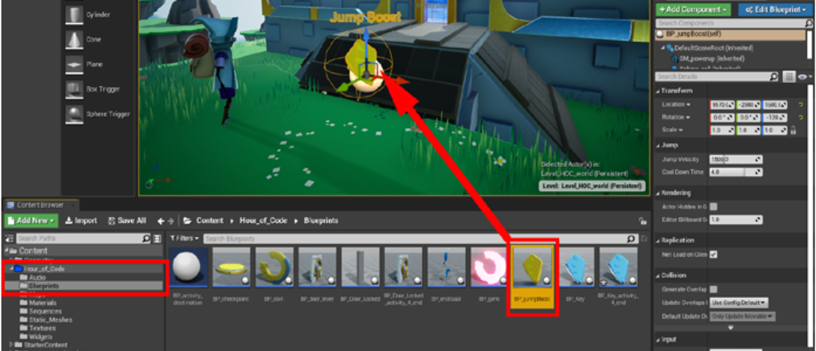
Figure 015 – Add the Jump Boost Blueprint to the level.

The HUD Blueprint
Now open the W_HUD Blueprint. Navigate to Content Browser > Hour_of_Code > Widgets and double-click W_HUD.
- In the Hierarchy panel, select T_jumpBoost.
- In the Details panel, scroll down and find Color and Opacity under Appearance, change the A (alpha) to 0.3; you will see the jump boost icon appear in the bottom left corner of the HUD (Figure 016).
- Click the Compile button at the top-left area of the screen and close the Widget Editor.
- Play the game to see that the jump boost appears as a semi-transparent icon in the left corner of the player’s screen.
When you collect the Jump Boost, you’ll notice that the icon doesn’t change yet. We’ll address that next in the Blueprint.
Remember to Save All your work. (File > Save All or CTRL-SHIFT-S)
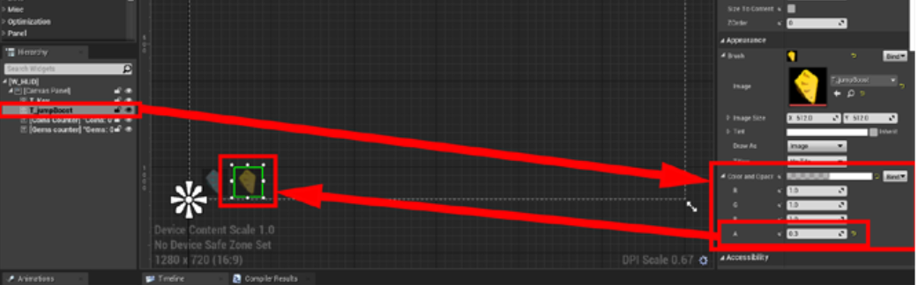
Figure 016 – Changing the alpha transparency value makes the jump icon appear on the HUD.

The Jump Boost Blueprint
Next, double-click the BP_jumpBoost blueprint to open it. We aren’t going to make you define all the code this time as it’s similar to what you implemented for the HUD key pickup. Instead, the completed code is ready for you to explore and then to connect:
- Click the Event Graph tab if it is not already open.
- You will notice a blue section labeled Activity 5, and inside is another section labeled “Connect me to PlaySound at Location”.
- Connect the execution pin from Play Sound at Location to the reroute node in this section (Figure 017). This will purposefully disconnect some existing code.
- Remember to Save All your work (CTRL-SHIFT-S).
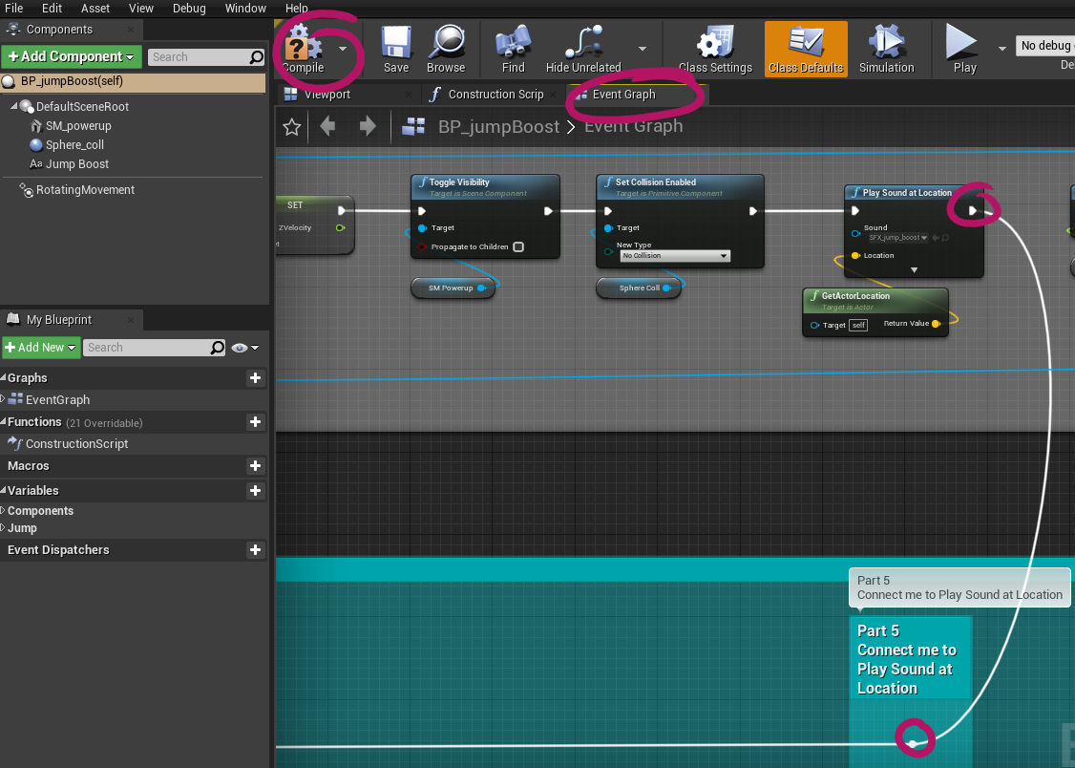
Figure 017 – Connecting the completed nodes to the blueprint.
You may notice that redirecting this wire from the execution pin will cut off the remaining nodes in the above section. It’s OK! We have included a copy of those nodes in this newly connected section for convenience.
Take some time to explore the nodes you just connected. Try to explain to yourself how the jump boost icon changes its alpha transparency while the power-up is active.
Now, play the game, collect the jump boost. The jump boost will now change opacity when the character touches it and will change again at 4 seconds (default value is 4) when the cool down timer expires.
🖖 LENDING A HELPFUL HAND
Did you notice the bug we just introduced? If not, play the game, grab the jump boost, and jump into the void. You’ll see that the HUD jump boost icon doesn’t reset to transparent when the character dies.
This is because the character is colliding with the Kill Z plane, which we talked about in Part 1. The Kill Z plane kills the player, but it does it a little differently than the Pain Causing Volume we introduced in Part 1.
This is a good example of what happens when working on a game. Often, a designer will implement a feature, and notice that in the process they have created a bug. We will address this bug in the next section.

BP_HourOfCode_Character Blueprint
Navigate to Content > Hour_of_Code > Blueprints > Game and open BP_HourOfCode_Character by double-clicking on it. Then click on the Event Graph tab if it’s not selected already.
You’ll see a few blue areas. Locate the area labeled Part 5. Zoom in to that area (using the mouse wheel and right-click drag) and locate the red hitKillZ node.
Connect the execution pin of the hitKillZ node, to the Cast to BP_HourOfCode_Game node (Figure 018). Then, click the compile button.
Now when the character is destroyed, it will also reset the opacity of the jump boost icon.
It’s time to playtest this to make sure that it is working correctly. Pick up the jump boost and fall into the void. When the character dies, the jump boost icon should reset.
Remember to Save All your work.
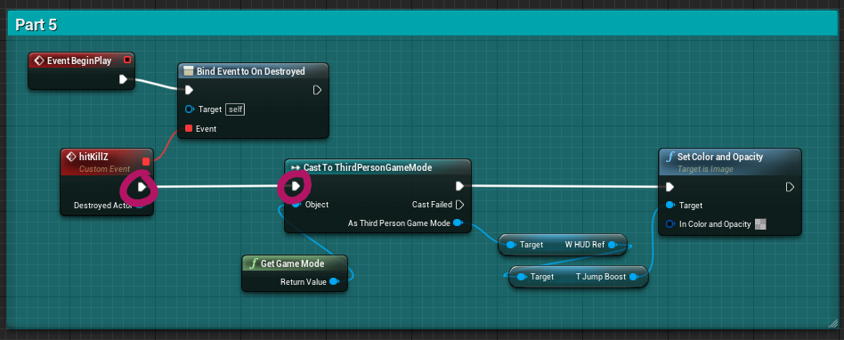
Figure 018 – Connecting the kill z fix code in the part 5 section of BP_HourOfCode_Character

Coins and Gems
In this section, we are going to reveal the coin and gem counters within the W_HUD Blueprint.
Before we get to the code section, we want to add a coin and a gem where we can easily access them. In the Content Browser, navigate to Content > Hour_of_Code > Blueprints folder and place a BP_coin and a BP_gem into your level. Remember, you can press W to activate the Move gizmo to reposition your objects (Figure 019).
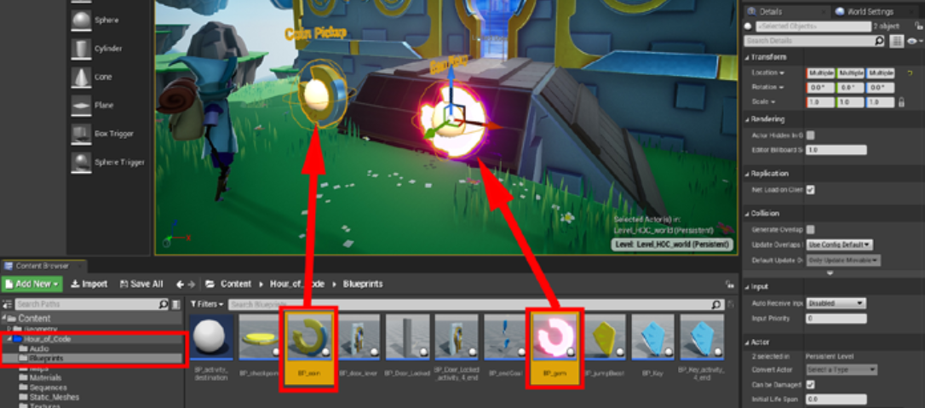
Figure 019 – Adding a Coin and a Gem to the level for testing.
- In the Content Browser, navigate to Content > Hour_of_Code > Widgets and open the W_HUD Blueprint.
- In the Hierarchy panel select the Coins Counter and the Gems Counter (to select both, you can click on Coins Counter and hold shift while clicking the Gems Counter).
- In the details panel, change the A (alpha) value of Color and Opacity to 1 (Figure 020).
- Then click the compile button.
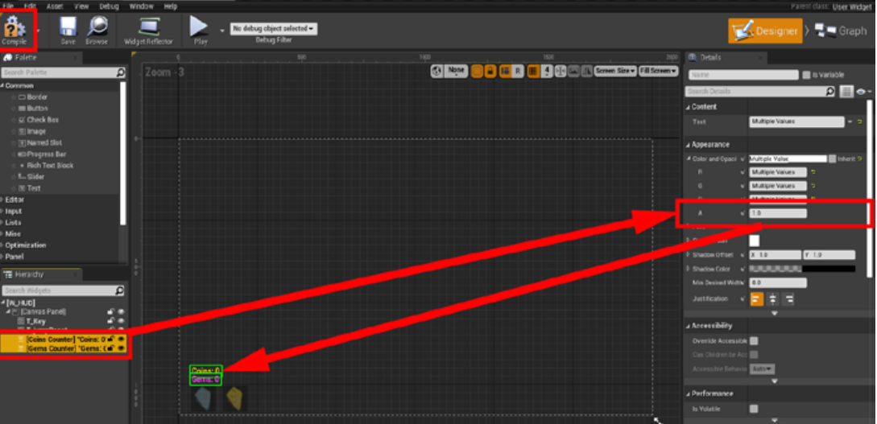
Figure 020 – Revealing the coin and gem counters.
Now play the game and pick up the coin and the gem. Watch the counters in the bottom-left area of the screen.
Did you notice the bug? The coin counter didn’t change. This is because the BP_coin Blueprint is missing a connection.
In the Content Browser navigate to Content > Hour_of_Code > Blueprints. Open the BP_coin and click on the event graph if it is not already selected and look at the code. Can you figure out what needs to be connected?
- Locate the blue area labeled Part 5.
- Connect the execution pin of the Set (Coin Count) node to the Update Coins event node (Figure 021).
- Then, compile the code and close the Blueprint editor.
- Play the game and you should notice that the HUD updates correctly now. Great work!
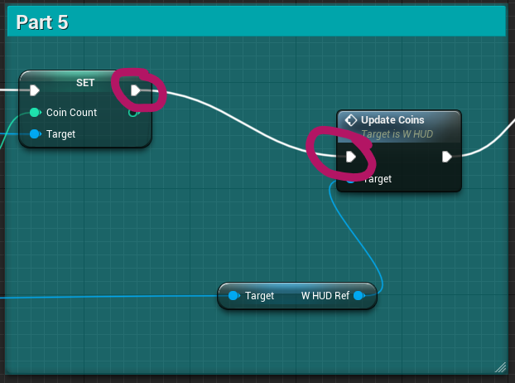
Figure 021 – Connecting the Set (Coin Count) node to the Update Coins node.

Keeping Score
Let’s take a quick look at how our game is keeping score. Open the W_gameCompletion Blueprint located in the Content > Hour_of_Code > Widgets folder of the Content Browser.
In the Designer view, you can see how each of the widgets is laid out. Now, select time in the hierarchy panel. Then, look at the top of the details panel, you will see a checkbox that says is Variable (Figure 022). This means that this widget can be used as a variable, and can be given information just like the coins and gems.
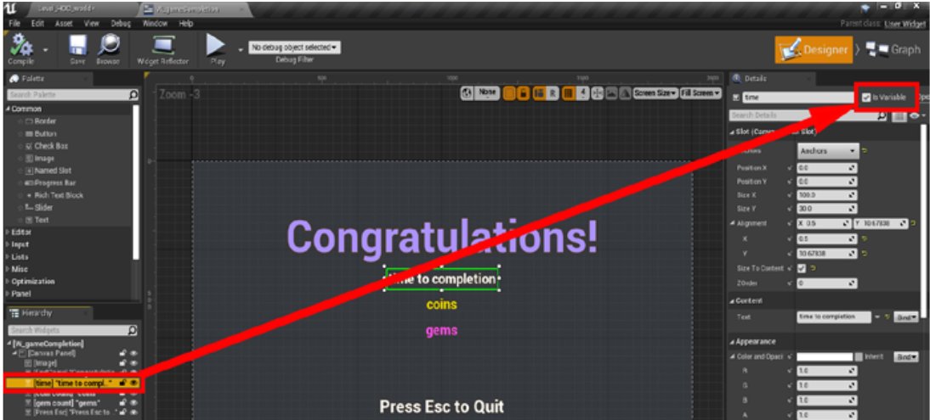
Figure 022 – The “is variable” checkout for the time widget.
Click the graph button and you will see 3 sections. The top section is reporting the time it took to complete the game. The middle section reports the number of coins the player collected. And the bottom section reports the number of gems the player collected (Figure 023).
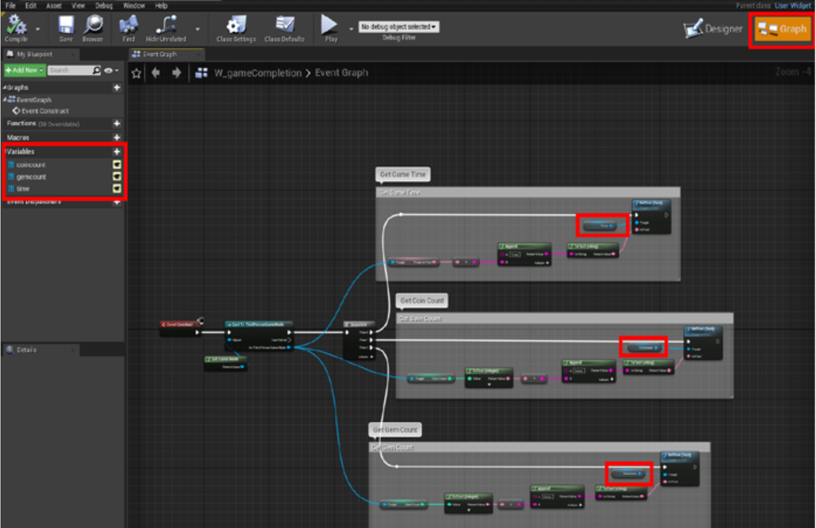
Figure 023 – Coins, gems, and time counters displayed as text.
By looking at this graph you can also see how the variables are being used as targets of the SetText node. Now follow the blue wires back, you can see that the game mode is where the data is being called from. Hover over a wire or node to see a tooltip with more information.
Remember that casting is one way that Blueprints can talk to each other. Here the HUD Blueprint is casting to the game mode to get information about the coins, gems, and the time it takes for the player to complete the level.
Even though we didn’t change anything in these Blueprints remember to Save All your work. It will be important for the last section.

Cleaning Up and Building Out
Take a moment to clear out all the testing Blueprint you added to the level including test coins, test gems, test jump boosts, and test keys.
Then play the game from start to finish with the HUD in place and note any places where the gameplay can be improved? Take some time and make these improvements.
It now also time to add a side quest for gems and coins. How you design this side quest is entirely up to you. Use all the game mechanics at your disposal: Floating islands, moving platforms, jump boosts, you can even use additional doors and keys!
Have some fun with it.

Play Testing
Now that you are done the game, you and your play testers should play the game from start to finish. Watch your play testers play the level, but don’t tell them where to go. Ensure that the HUD and the end game screen are working as expected. Observe where your play testers get frustrated or where they get lost. Use these observations to improve your platform sequences to make the journey more fun.

Packaging the Game
With all the work you have completed in this course, let’s package up the game so you can add it to your portfolio or just send it to your friends.
We will need to make sure that they can quit the game when they want to though. To do this, open the BP_HourOfCode_Character blueprint from the Content > Hour_of_Code > Blueprints > Game folder of the Content Browser.
Locate the blue area labeled Esc to quit inside the DEBUGGING area (Figure 024). Then connect the pressed execution pin to the Quit Game node (Figure 025). Then compile and close the Blueprint Editor. Save All of your work.
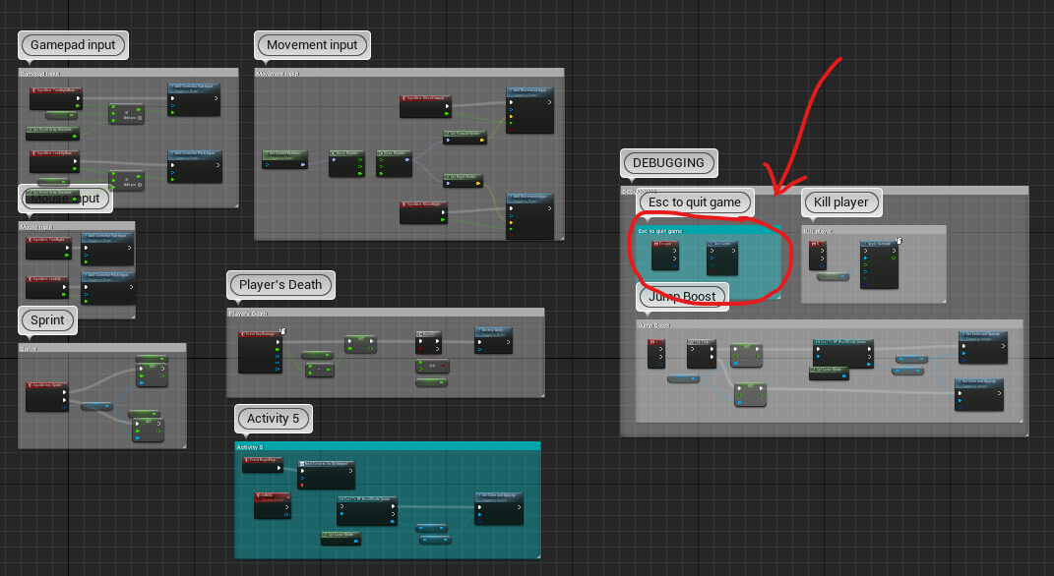
Figure 024 – Locating The Correct Section To Edit
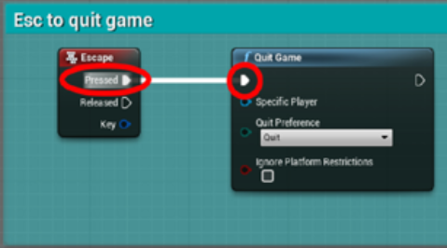
Figure 025 – The escape key will now quit the game.
To package the game, click the Platforms button on your Level_HOC_world level then select Windows and then Package Project. You will then need to pick the location where you wish to save your packaged project (Figure 026).
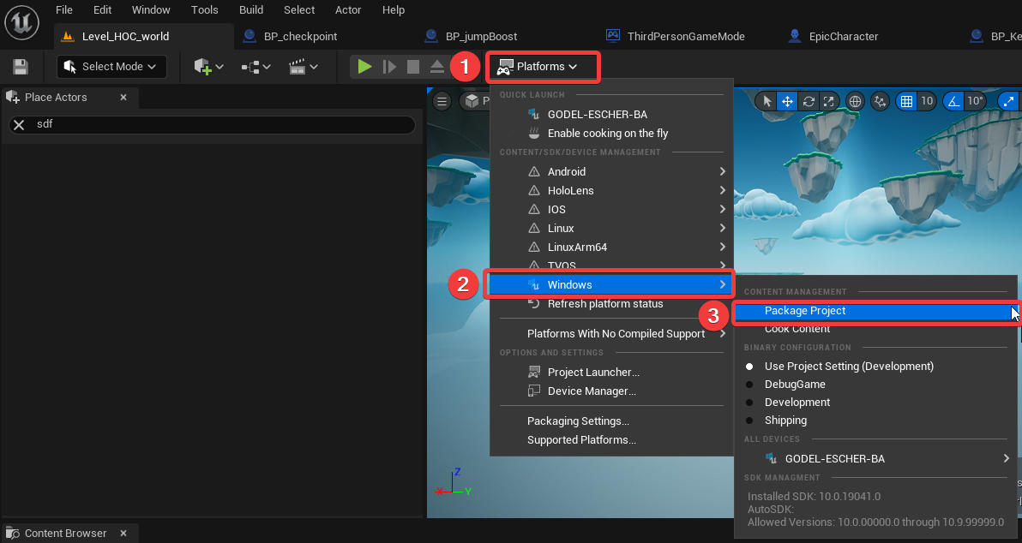
Figure 026 – Packaging the game for Windows.
Once the game has been packaged up you will see a folder called Windows. You can rename this folder if you wish. Simply open that folder and double-click on the *.exe file to play the game.

Part Five Completed!
Congratulations! You have completed the project. You now have enough knowledge to know what sorts of questions to ask as you get further in your game development journey. Keep this project for your notes and refer to it as needed.

What’s Next?
You are now done all five parts of this first project. In your next project you’ll learn even more about Unreal Engine by implementing a twin-stick shooter from scratch. The final thing you need to do for this project is to record a walkthrough screencast of your level and zip up your project for submission.

Level Walkthrough Screencast
Part of what you will need to submit for this project is a screencast recording of your level. Your screencast needs to include:
- Video of the player experience from start to finish.
- Voice over commentary of the various level design elements.
- The functionality of the elements you added throughout this project. (See rubric for details.)
- An overview of any additional side-quests you added to your level.
- A lovely starting title screen.

Videos can be recorded using OBS, Powerpoint, or any other screen recording tool. They can be edited using the simple Video Editor built into Windows Photos Legacy, which can also be used to add the starting and ending title screens. Please keep your video short (approximately 5 minutes or enough to record your entire playthrough).
Completed videos should be uploaded to YouTube as “Unlisted Videos” and the video URL should be included at the end of your developer journal.
Your instructors will review the screen recording, editing, and upload process in class.

Project Submission
You only need to submit your Unreal Engine project, not the executable project build. For the submission, instead of just zipping up your project folder from Windows Explorer, you should instead create a project zip file from within Unreal. This will ensure that only the necessary files get included in the zip. You can create this zip file by selecting “Zip Project” under the “File” menu (Figure 027).
If your zip file is under 2 gigs in size, you will be able to submit it by way of the Learn dropbox. For larger projects, your instructor will walk you through an alternative submission process. Note that the alternative submission process must be completed while on campus.
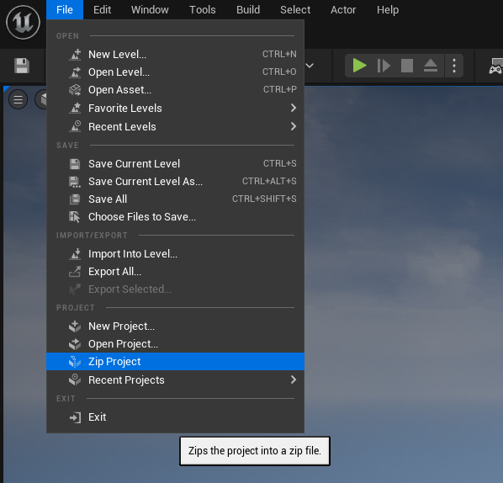
Figure 027 – Creating Your Project Zip File for Submission

🚀 Your Progress: COMPLETE!


Further Reading
- Official UMG UI Quick Start Guide
- Official UMG UI Designer – How To Guide
- Official UMG Designer User Guide
- Your First Hour with UMG – Official Video Course
- Official Guide to Packaging Unreal Projects

